Registration Number: NI066402
Verification, Validation and Test Handbook
Version: | 1.0
Status | Draft
Date: | 14th July 2008
Approved: | Andrew Brown

Table of Contents
1.1 Objectives and Scope 3
1.2 Terms and Abbreviations 3
2 Introduction 3
2.1 Amendment Record 3
3 VV&T 4
3.1 Lifecycle 4
3.2 VV&T Handoff 4
3.3 VV&T Test Cycle 5
3.4 First Office Application (FOA) 5

Objectives and Scope
This handbook forms part of the Feature Creep QMS. The handbook is primarily targeted at people involved in the testing of products. It may be considered as a Work Procedure for product quality assurance. This handbook must be read in conjunction with the Feature Creep Delivery Framework, which details how the Feature Creep product development lifecycle is monitored and controlled.

Terms and Abbreviations
FS Functional Specification
IOT Interoperability Testing
MRD Marketing Requirements Document
PAC Performance and Capacity
PDT Product Delivery Team
PPG Product Planning Group
PRD Product Requirements Document
QA Quality Assurance
QMS Quality Management System
SIT System Integration Testing
VV&T Integration, Validation, Verification & Test

Introduction
This handbook will outline the approved methods and procedures employed by Feature Creep to ensure the highest possible quality of Product Release and Solutions
VV&T has responsibility for the following four main areas:
- Functional VV&T
- Load & Stress Testing
- Interoperability Testing
- Homologation and Certification

Amendment Record
Date | Issue Number | Reasons for change
14th July 2008 | 1.0 | First draft for review

The Quality System is subject to continuous review and improvement. Note that updates to this manual since the previous version are shown by change bars.

VV&T

Lifecycle
VV&T activities should be ongoing throughout the development lifecycle, from PRD production right through to code production and integration test. 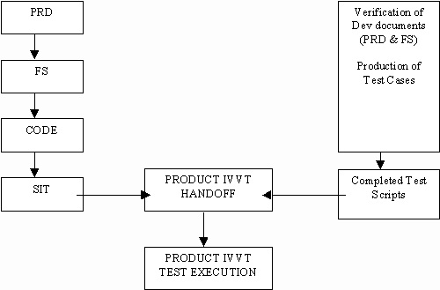

The VV&T team should be developing test cases in parallel with the ongoing development lifecycle. For example, VV&T will be involved in the review of the PRD document which will enable test cases to be written that will directly correlate to each of the specified requirements. The VV&T team should also have significant input during code reviews and initial integration test, although ultimate responsibility for the output produced from both of these phases rests with the Development team.
Critically, VV&T must define the quality related release criteria at the Development Commit gate defined within the Feature Creep Delivery Framework. These criteria must be satisfied at the subsequent Release Gate.

VV&T Handoff
When System Integration Testing is complete, VV&T must receive a formal handoff document from Development (usually in the form of an email) which should state that a handoff release is ready to enter the VV&T Testing phase and must also contain details on the following:
- Bugs fixed in the release
- Installation Instructions
- Any additional information that installers / users should be aware of.
All of the agreed software functionality must be in a working and testable state before VV&T receives the handoff email. VV&T must ensure that the following statements are true before accepting the software into a test execution cycle.
- Software is installable
- System Builds
- Software is testable
- All functionality present
VV&T should accept or reject the handoff and communicate the reasons for their decision, usually in the form of an email.

VV&T Test Cycle
The VV&T Test Cycle will now commence, once all test cases have been written and all necessary test tools have been developed. The following activities will then be performed:
- Execute Test Cases (including Load tests)
- Any bugs identified raised in trouble ticketing system
- Automation of Test Scripts (where required)
The release criteria specified at Development Commit must be satisfied to exit the VV&T Test Cycle. Typically these will include:
- All new functionality has been verified
- Agreed proportion of pre-existing functionality has been regression tested
- Code coverage targets specified at Development has been achieved
- All requirements in the VV&T Traceability Matrix have been tested
- Number of bugs of each severity measured and these numbers should not exceed the limits specified in the release criteria
- Evidence that defect rate is rapidly decreasing
- No defects in an inconclusive state (awaiting retest, further information etc)

First Office Application (FOA)
The objective of FOA is to provide on-site verification of Feature Creep’s product and features required by the customer for the product under FOA. The software under test will be a pre-GA (Generally Available) controlled release for purposes of testing within the customers environment. This ensures that the carrier has the opportunity to gain confidence in the new product under test and gaining an early insight to the new functionality whilst also assisting product quality. This process should assist the customer in reducing their time-to-market by reducing the time to complete acceptance testing of the product.
The FOA Project Manager will provide a Statement of Work (template) which should cover all aspects of the FOA activities, such as:
- Milestones
- Responsibilities of the Feature Creep FOA team during FOA period
- Responsibilities of the Customer during the FOA period
- Resources Required
- Scope of FOA work
- Requirements Traceability
- Required Metrics
- Progress Reporting
- Exit Criteria out of the FOA release

